1. How to setup an Arduino
   1. Download the Arduino IDE from <https://www.arduino.cc/en/software>
   2. Install Arduino IDE
   3. Connect your Arduino device to your computer using both USB and Ethernet Cable (You might use a USB to Ethernet Converter)
   4. Locate the Arduino liquid crystal INO File from –\builds\Device builds\ArduinoLiquidCrystal\INO File
   5. Copy the file to your local drive and edit the following –

* 1. Edit the byte mac address to the one listed on your Arduino device’s ethernet shield.
  2. Edit the IP address as follows –
     1. Make sure that your Arduino is connected to your computer using an ethernet cable
     2. Go to Control Panel\Network and Internet\Network and Sharing Center
     3. Click on the network connection of your Arduino device

* + 1. Go to properties

* + 1. Select Internet protocol Version 4 (TCP/IP) and click properties or double click and change the settings to the following. Incase 192.168.16.1 is occupied change it to whichever one is open and does not conflict with the rest of your network. Click okay

* + 1. In the script, go to the ip tab and input the same ip address. However, change the last digit to some number that is not occupied.

* 1. Verify and then upload the code to your Arduino device using the Arduino IDE

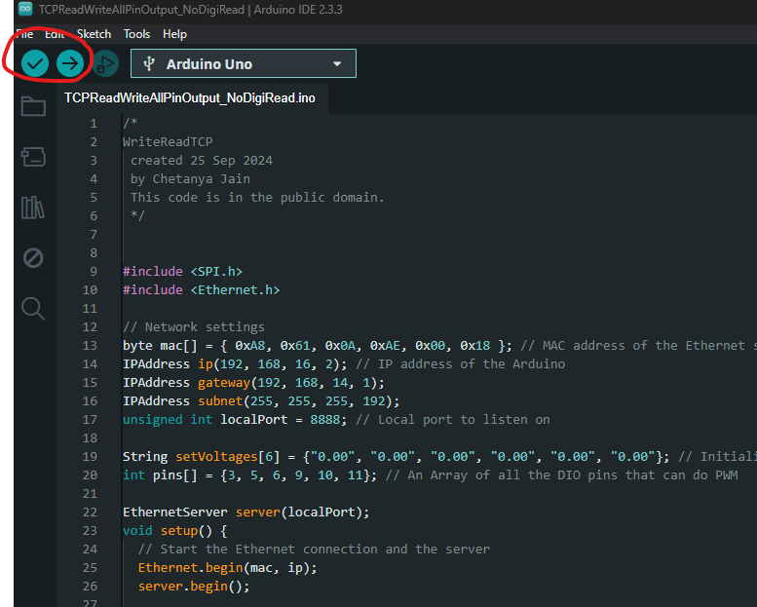

* 1. The serial monitor on the Arduino IDE should read –

* 1. Disconnect the USB cable from the Arduino and computer.

1. Setting up the device on GEECS
   1. Go to Database Editor > Device Ops > Device > Device (Add)
   2. Add the relevant details. The IP Address corresponds to the IP Address of the computer you are setting up your device on.
   3. Go to Device variable Ops > Device Variable and find your device.
   4. Set the connection type to TCP/IP
   5. Set the resource name to the same IP address as the Arduino device.
2. Start the device in Master Control